Civil war in Somalia

UNSC Resolution: | 1425
Date of adoption: | 22-Jul-2002
Operative paragraph: | 6
Demand number: | 1425,0611

Sarah-Myriam Martin-Brûlé

Wording of demand

cooperate fully with the Panel of Experts in its quest for information in accordance with this resolution, including by facilitating visits to sites and actors and by providing full access to government officials and records, as required by the Panel of Experts

List of addressees of the demand

Government of Somalia, United Somali Congress Faction

Short-term compliance

Description of the addressee(s)’ conduct
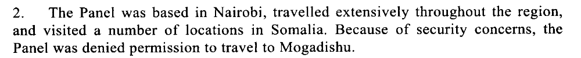

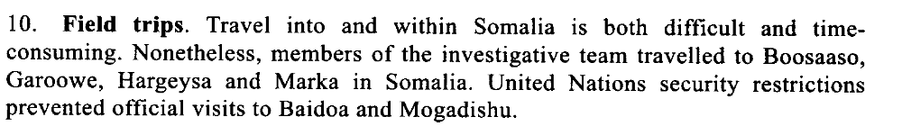
Report of the Panel of Experts on Somalia Pursuant to Security Council resolution 1425 (2002).

Assessment

Short-term compliance
X No or marginal compliance (1) | Medium low compliance (2) | Medium high compliance (3) | Full or almost full compliance (4)

Considerations underlying the assessment

Medium-term compliance

Description of the addressee(s)’ conduct

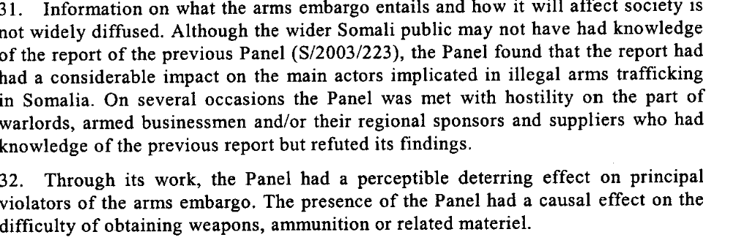
Letter dated 4 November 2003 from the Chariman of the Security Council Committee established pursuant to resolution 751 (1992) concerning Somalia addressed to the President of the Security Council.
“The Council had before it a letter from the Chairman of the Committee established pursuant to resolution 751 (1992) concerning Somalia, which contains a report of the Panel of Experts mandated to collect independent information on violations of the arms embargo on Somalia and to provide recommendations on possible steps for its implementation (document S/2003/223). The Secretary-General appointed the Panel for a six-month period last September, in pursuance of Council resolution 1425 (2002).
By that text, the Council requested all States and the Transitional National Government and local authorities to cooperate fully with the Panel of Experts, including by facilitating visits to sites and actors and by providing full access to government officials and records. However, the Panel deems that a number of States, in particular Djibouti, Eritrea and Ethiopia, and the Transitional National Government, have not lent their full cooperation to the investigation.”
Security Council Re-Establishes Panel Investigating Somalia Arms Embargo Violations, Unanimously Adopting Resolution 1474 (2003), 9 April 2003.

Assessment

Medium-term compliance
X No or marginal compliance (1) | Medium low compliance (2) | Medium high compliance (3) | Full or almost full compliance (4)

Considerations underlying the assessment

Within the two years following the adoption of the demand, the demand addressees did not cooperate fully with the Panel of Experts in its quest for information in accordance with this resolution, including by facilitating visits to sites and actors and by providing full access to government officials and records, as required by the Panel of Experts.

Depth of demand

Assessment

Level of depth of demand
X Low depth of demand (1) | Medium depth of demand (2) | High depth of demand (3)

Considerations underlying the assessment

Cooperation with the panel of experts in their quest for information would not have put the survival of the demand addressees at risk nor would it have significantly impacted on their chances to gain power.

Level of confidence about coding decisions

Level of confidence about coding decision
Extremely high | X High | Moderate

Comments to IPI (if any)

